Jump to: Step-by-step About this Topic Tips Related Topics

# Step-by-Step

## Control Level

Step 1. Using the Navigation Panel on the left side of the screen, select the Department.

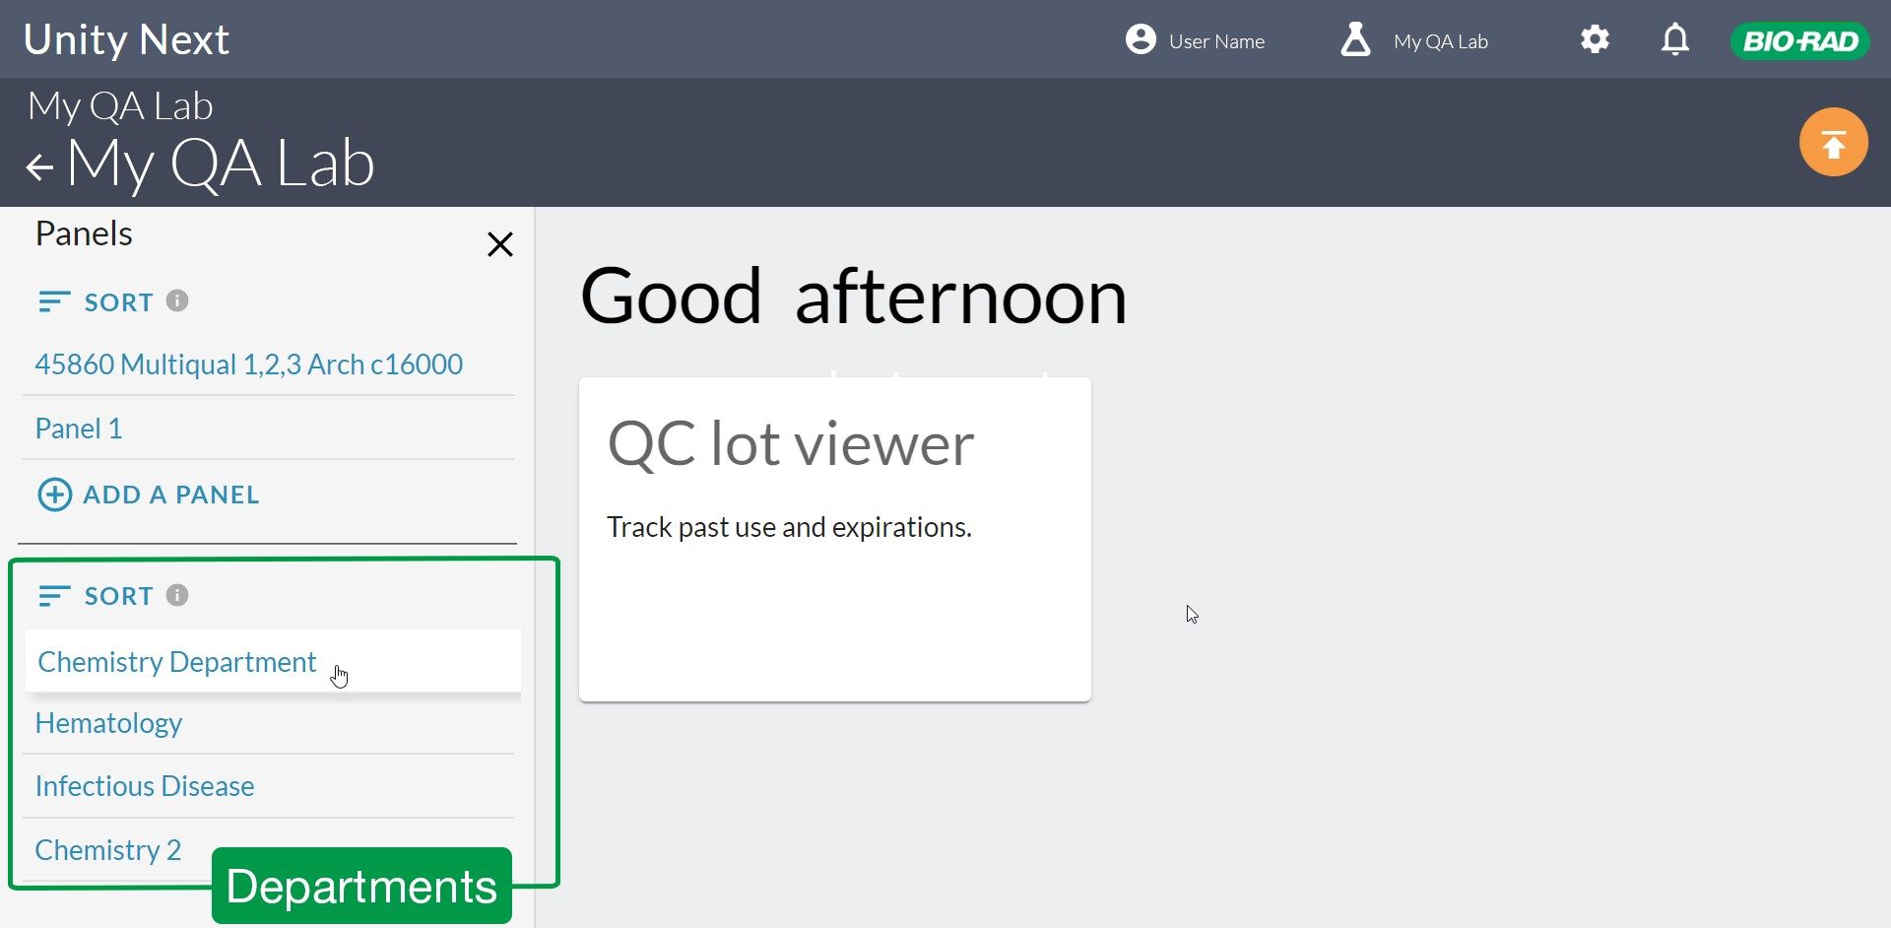

Step 2. Select the Instrument.

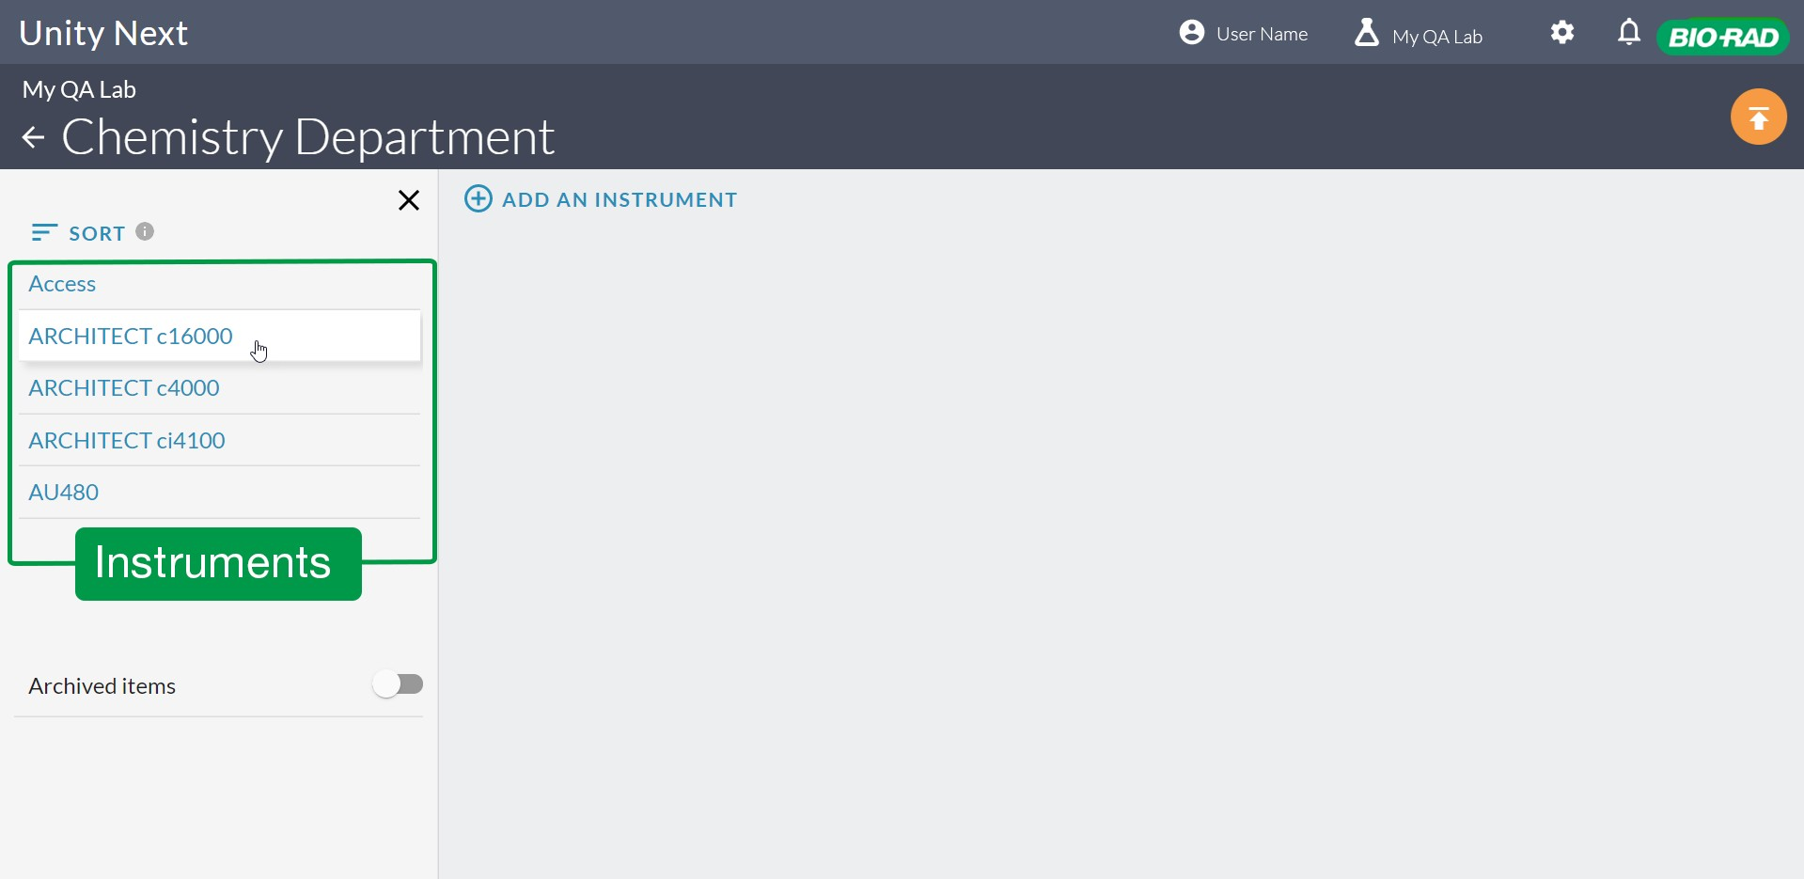

1. Select the Control Name.
2. Click **Edit this Control** at the top of the screen.

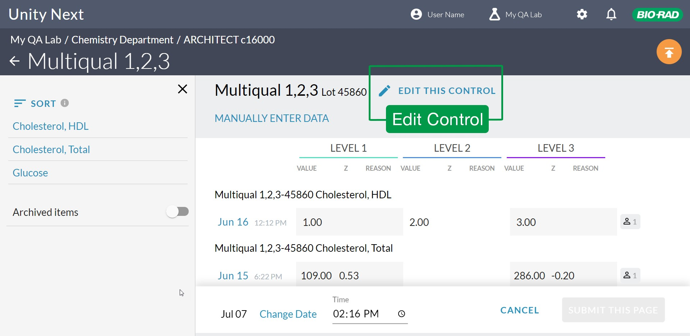

1. Click a radio button to choose either summary data or point data.

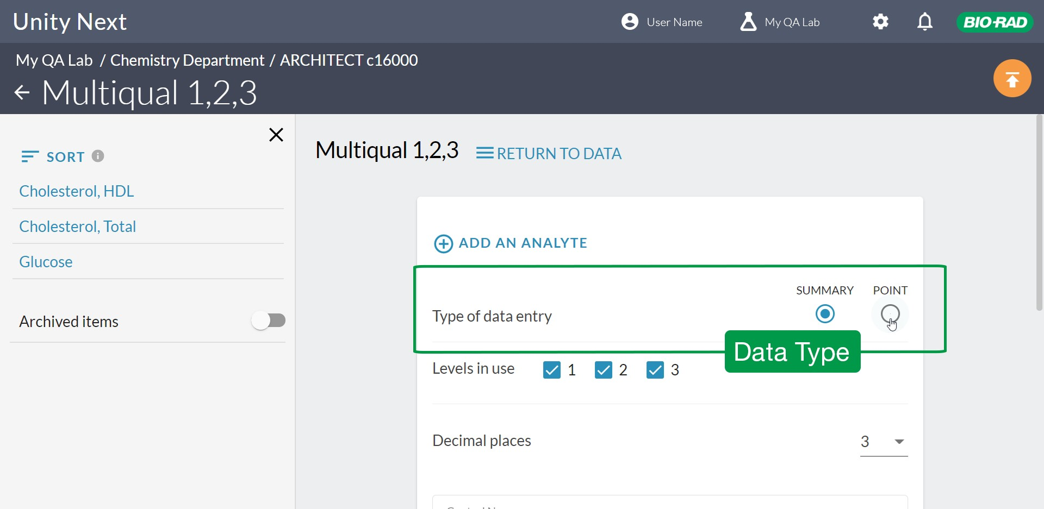

1. Select which levels you use for this QC product (Levels in use).
2. Select the number of decimal places you need to enter.

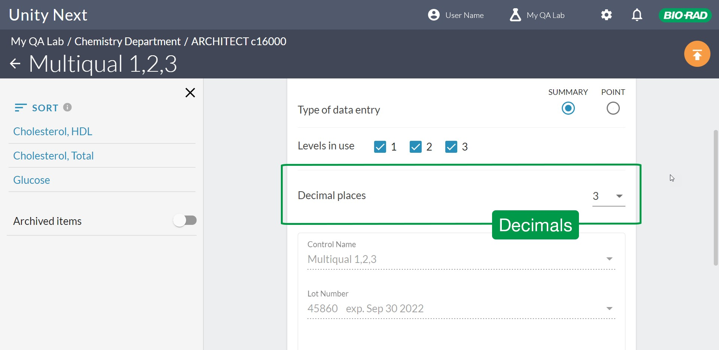

1. Scroll down and click **Update**.

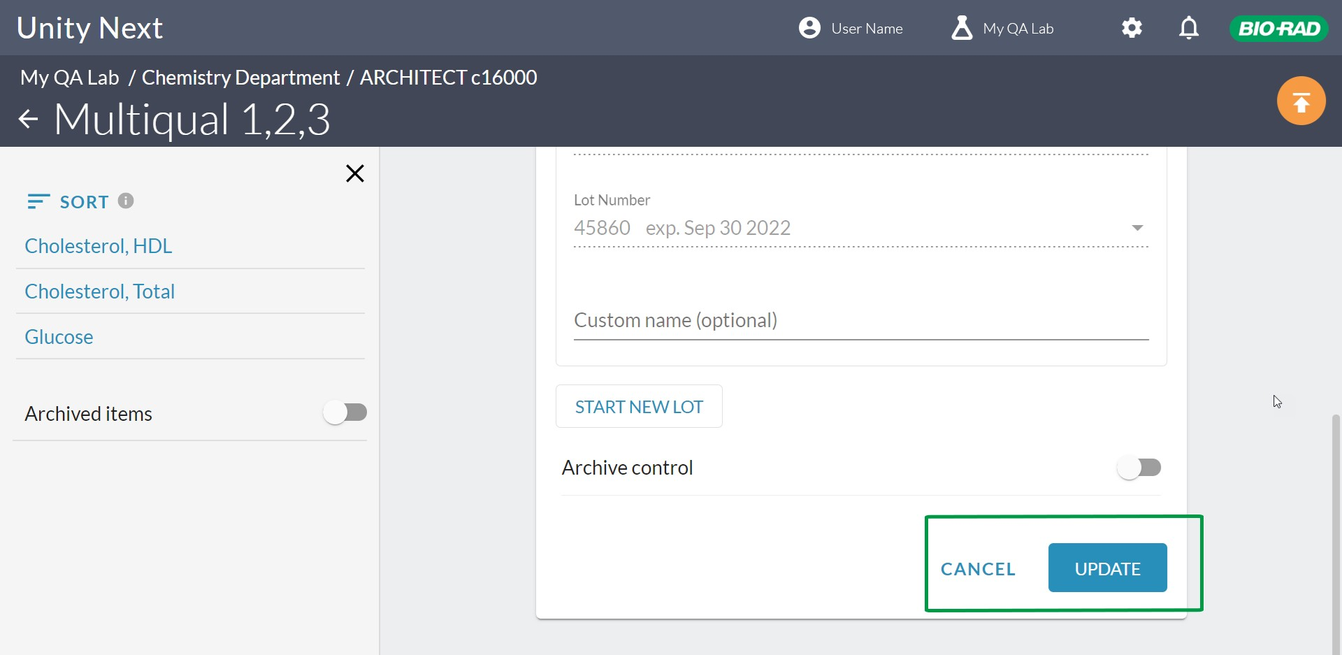

## Analyte Level

1. Using the Navigation Panel on the left side of the screen, select the Department.



1. Select the Instrument.



1. Select the Control Name.

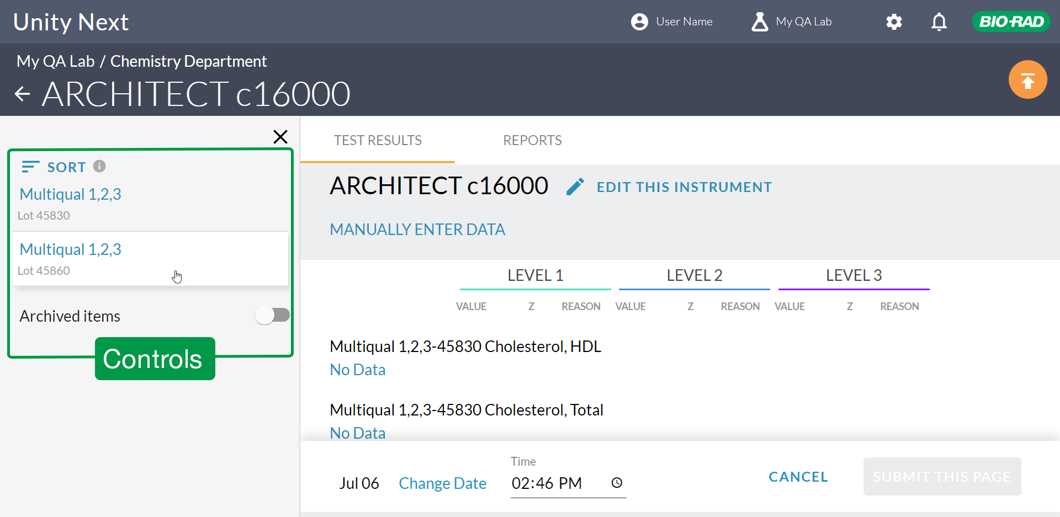

1. Select the Analyte.
2. Click **Edit this Analyte** at the top of the screen.

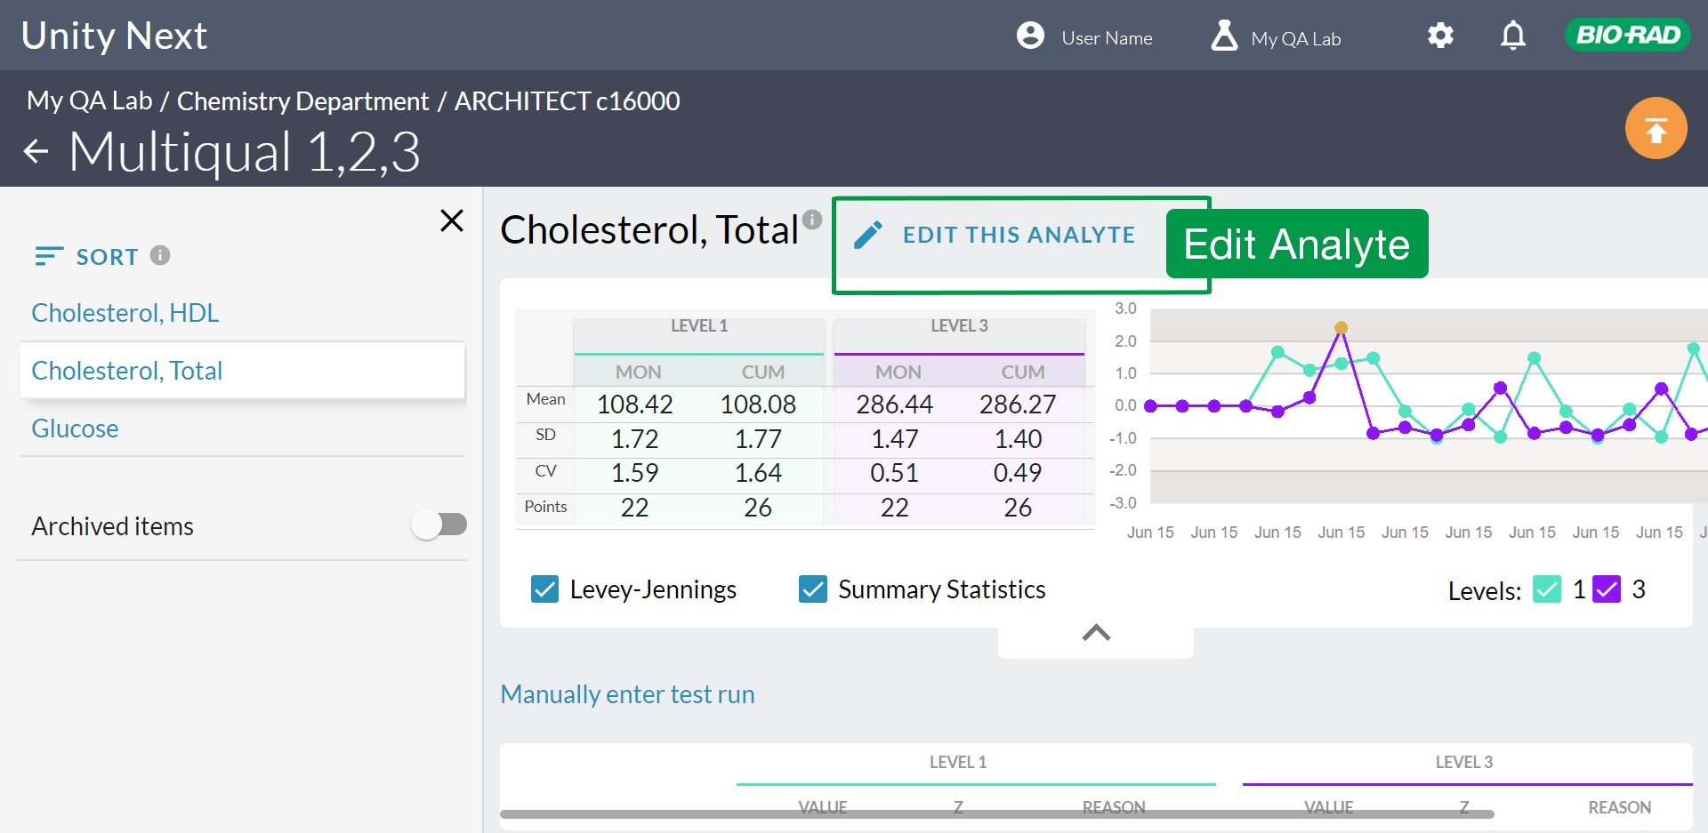

1. Select which levels you use for this analyte.

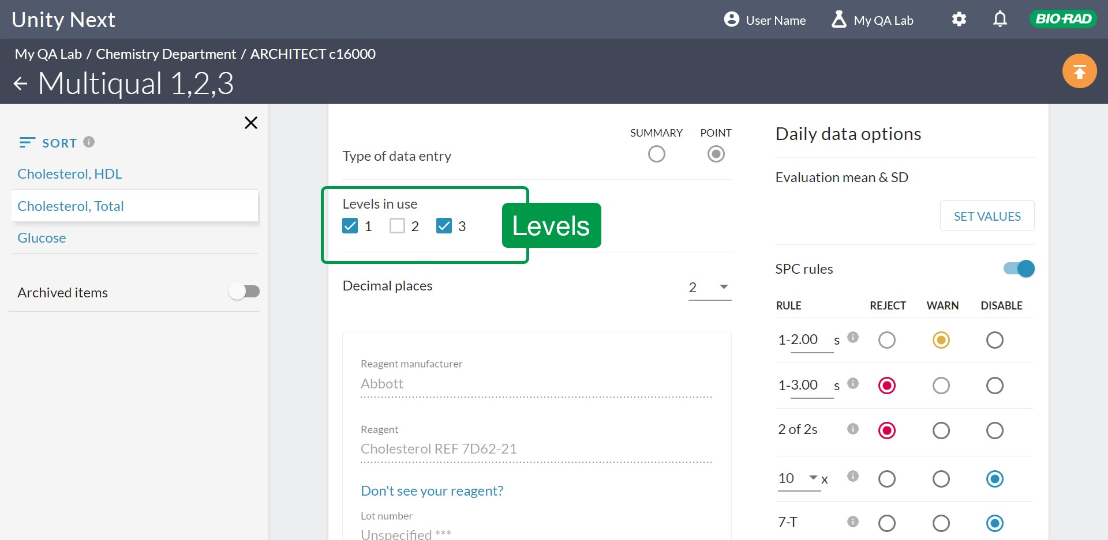

1. Select the number of decimal places you need to enter.
2. Scroll down and click **Update**.

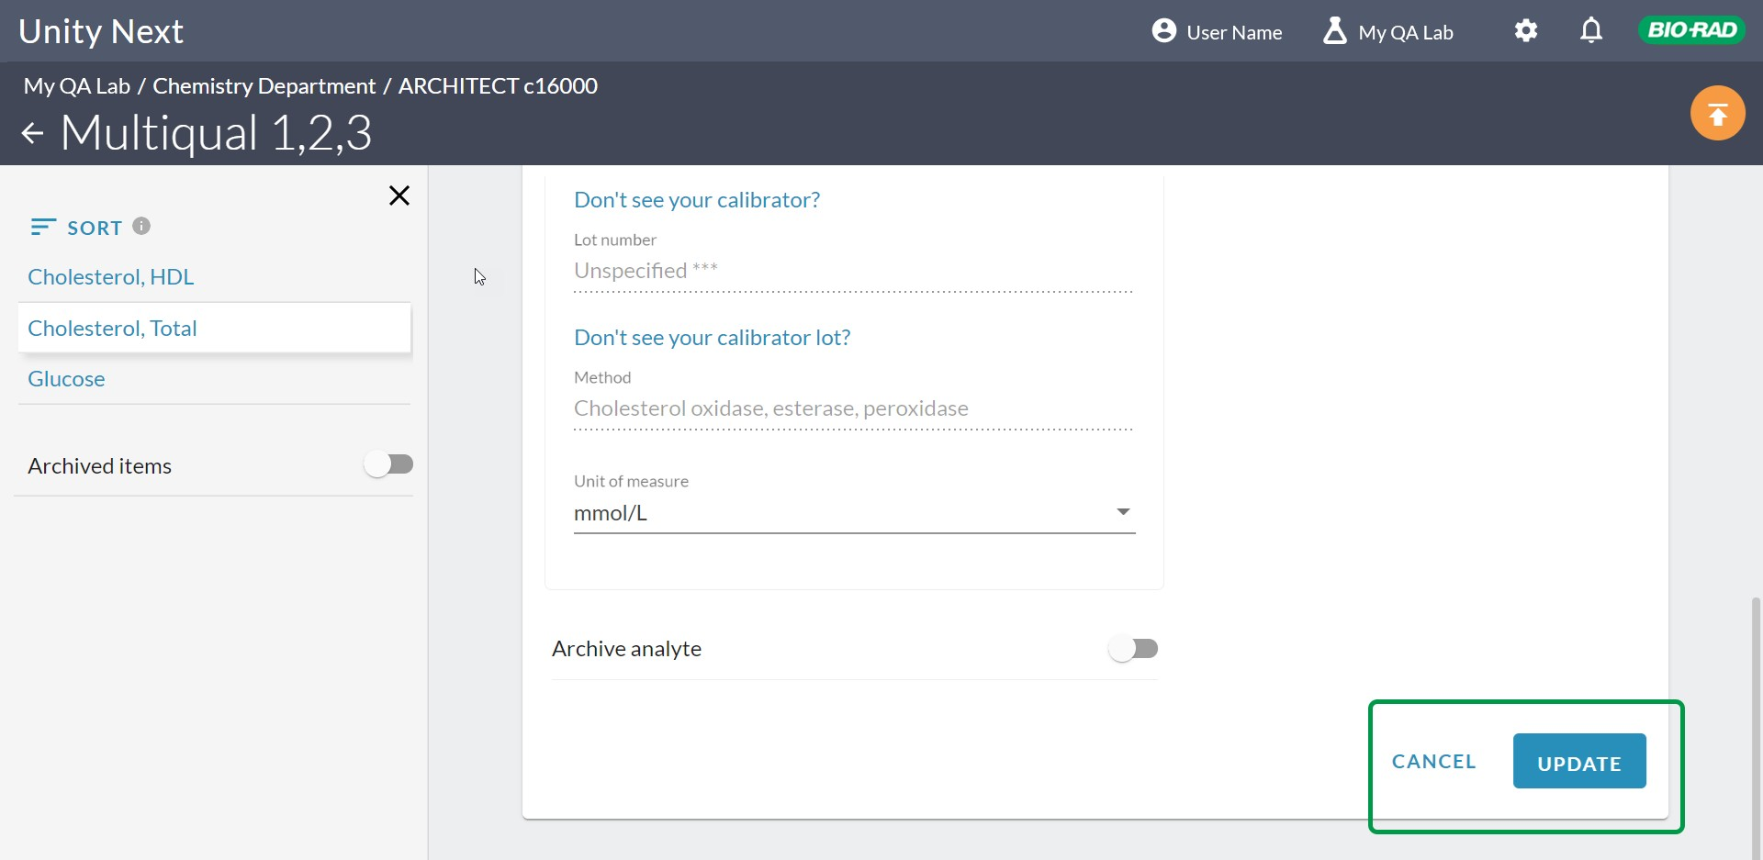

# About setting up data entry type, test levels and decimals.

### **Point Data**

For Point data, toggle SPC rules on/off after you click **Edit this analyte**.

### **Set Evaluation Mean and SD**

Click the **SET VALUES** button to set your Evaluation Mean and SD.

### **How to Delete**

Click the red trash can icon to delete a control or an analyte.

### **How to Archive**

Toggle **Archive analyte** on/off to remove the data from submissions to Bio-Rad. Use Unarchive to restore to data submissions. See [Archiving](https://qcnet.zendesk.com/hc/en-us/articles/360061944531) to learn how to use Archive to manage your data.

### **Tips:**

Enter one decimal place more than you include in patient reports.

Related Topics

Data entry Test levels

Edit an analyte

Add analytes to a control Summary data for single test Point data for single test Archive